**LAB 12 EXERCISES**

**QUESTION # 1**

Write a C program to create 2 text files and store some text inside them. Then read these 2 files into the program and merge the text into a 3rd text file.

**QUESTION # 2**

Write a C program to count the occurrences of each letter in an existing text file and store this information into a new file, showing the occurrences of each letter and the total characters read in the following format:

A (Occurrances of A/a)

B (Occurrances of B/b)

C (Occurrances of C/c)

.

.

.

Total characters read = (Total characters)

**QUESTION # 3**

Write a C program to keep records and perform statistical analysis for a class of 20 students. The information of each student contains ID, Name, Sex, quizzes Scores (2 quizzes per semester), mid-term score, final score, and total score. All the records must be store in the file and you must read the scores <50, <80 and <100 until users selects the end file option.

**QUESTION # 4**

You’re the owner of a hardware store and need to keep an inventory that can tell you what tools you have, how many you have and the cost of each one. Write a program that initializes the file "hardware.txt" to 10 empty records, lets you input the data concerning each tool, enables you to list all your tools, lets you delete a record for a tool that you no longer have and lets you update any information in the file. The tool identification number should be the record number. Use the following information to start your file:

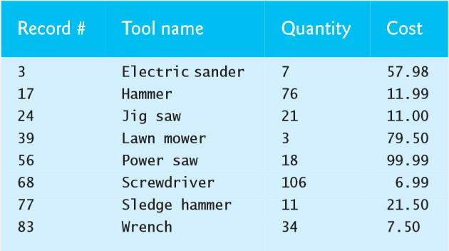

**QUESTION # 5**

Create a structure to store Student data. A student has RollNo, Name, Department, Batch, Section, CGPA. Store the information of N students using **array** and store it into a file. Then access the file to find out the following information:

* Given a user input of “RollNo”, print all the data of that student on the screen.
* Loop through the array of students and only print the data of students who are in Batch 2022

**QUESTION # 6**

Write a C program to read an existing text file, and encrypt it and save the encrypted version in a new file according to the following rules:

1. Each vowel must be replaced by “vow” or “VOW”. It should be lowercase if it is the 1st,3rd,5th vowel (odd num in the file (odd numbers) and uppercase if 2nd, 4th, 6th etc (even numbers).
2. Every 3 letter sequence of characters containing “s” must be replaced with PF-Lab.
3. After the above changes, use a normal shift cipher and replace every letter in the file with the letter which is 3 letter after. For example, A will be replaced by D, B replaced by E, Z replaced by C and so on.